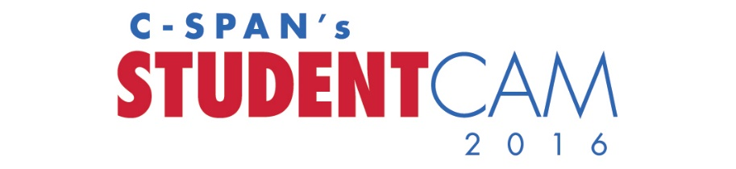CABLE LOGO

(MSO) and C-SPAN Invite Students to Compete in National Documentary Competition with $100K in Prizes
(City), (Date) – (MSO) and C-SPAN are calling for entries in C-SPAN’s 2016 StudentCam competition. Now in its twelfth year, C-SPAN’s national contest invites all middle (grades 6-8) and high school students (grades 9-12) to produce a five- to seven-minute video documentary using C-SPAN programming.
This year, students are being challenged to produce a documentary that focuses on the topic: “Road to the White House: What’s the issue YOU most want candidates to discuss during the 2016 presidential campaign?”
The deadline for students to submit entries is Wednesday, January 20, 2016; one year from the next presidential inauguration.
The C-SPAN Education Foundation awards 150 student and 53 teacher prizes, totaling $100,000 in cash. The grand prize winner with the best overall entry will be awarded $5,000 and multiple cash prizes of $3,000, $1,500, $750, $500, and $250 will be awarded to students in both middle and high school categories.
High school students will be competing on a regional level with the U.S. divided into three regions. Middle school students will continue to be judged on a national basis. The grand prize winner will be chosen nationally between all middle and high school entries. The specific breakdown of regions and rules can be found at www.studentcam.org.
“StudentCam provides our youth with an opportunity to think critically about issues that affect the nation, and a platform where they can express their opinions,” said Craig McAndrew, C-SPAN Education Relations Manager. “Nearly 5,000 students participated in the competition last year, and we look forward to hearing the thoughts of even more young people this year.”
(CABLE QUOTE)
Competition Guidelines
Entries must represent varying points of view and include C-SPAN video that supports the documentary’s topic. Students, working alone or in groups up to three, can upload their entry form and video directly online at www.studentcam.org. Documentaries must be the original work of students; however, teachers may provide guidance and critiques.
The documentaries will be judged by a panel of C-SPAN representatives and educators and evaluated on a number of criteria, including the thoughtful examination of the competition’s theme, quality of expression, adherence to the time limit, inclusion of varying points of view, and use of C-SPAN programming.
Winners will be announced in March 2016, with the top winning videos to air on C-SPAN in April 2016. Complete competition details and the entry form are available at the competition’s website, www.studentcam.org.
About C-SPAN Classroom
StudentCam is sponsored by C-SPAN Classroom, a free membership service dedicated to supporting educators’ use of C-SPAN programming in their classes or for research. Members of C-SPAN Classroom may access free Timely Teachable Videos, Bell Ringers, lesson plans, and handouts. C-SPAN Classroom has reached more than one million students since its inception in 1987.
About C-SPAN
Created by the cable TV industry and now in nearly 100 million TV households, C-SPAN programs three HD public affairs television networks; C-SPAN Radio (90.1 in the Washington Baltimore area; nationwide at c-span.org, through the C-SPAN Radio app, and on XM Channel 455); and a video-rich website which hosts the C-SPAN Video Library. Visit www.c-span.org to learn more.

(About MSO)
###

Contacts:
Pam McGorry in C-SPAN’s Education Relations Department
202-626-4861
pmcgorry@c-span.org
(Cable contact)

